**Science**

Looking after the environment

Living things and their habitats

**Art and D.T**

DT- Electrical systems

Art- Exploring how artists use light, form and colour to create immersive environments.

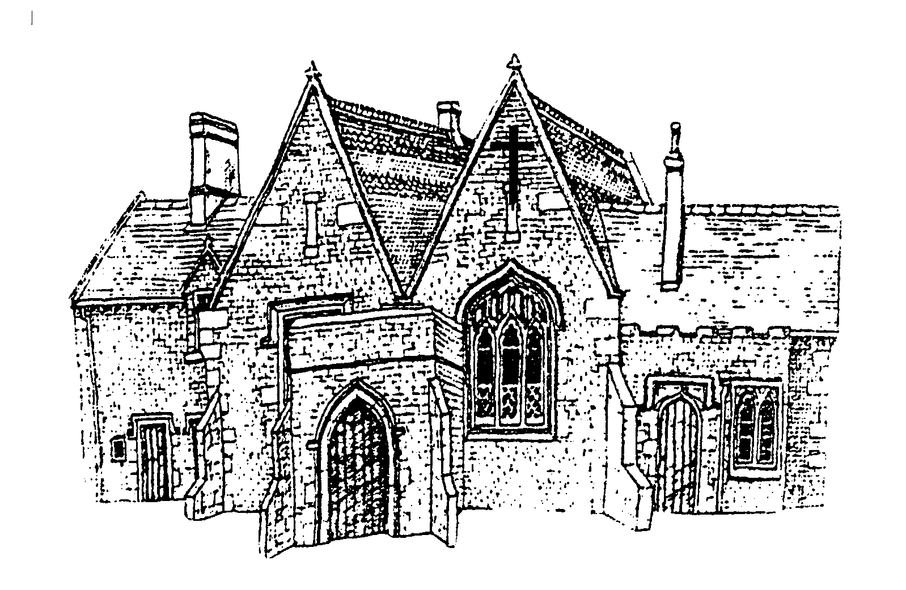

Cubbington CE Primary School

Year 6- Kites

Summer 2025

**P.E**

Rounders

Athletics

American football

Tennis

**Geography- Coasts**

The children will be completing a coastal study. They will learn what causes coastlines to change, features of a coastline, human use of the coast and the impact upon their lives and protection of coastal flooding.

**English**

Using the text ‘The Arrival’ to write our own extended version of the narrative, letters, character descriptions, diaries, playscripts and reports.

Using the text ‘The Promise’ to write letters in the role of characters, summary poems and diary entries.

**Music**

Developing their listening, composing and performing skills in unison and several parts using voice and percussion, with music linked to seasonal themes.

**RE**

What is the truth and where might it be found?

How can following God bring freedom and justice?

**Other information**

SATs week 2025- Monday 12th May to Thursday 15th May 2025

Pizza Express trip on 24th June 2025

Year 5/6 play Tuesday 1st July 2025

Warwickshire Transition Day Wednesday 2nd July 2025

Residential- Monday 7th July to Wednesday 9th July 2025

**Maths**

Shape

Position and direction

Problem solving projects

**PSHE**

Sex and relationship education: Healthy relationships/ How a baby is made?

**Computing**

Networks

Quizzing

Understanding Binary

Spreadsheets Microsoft excel

**French**

Our precious planet

This is France