7

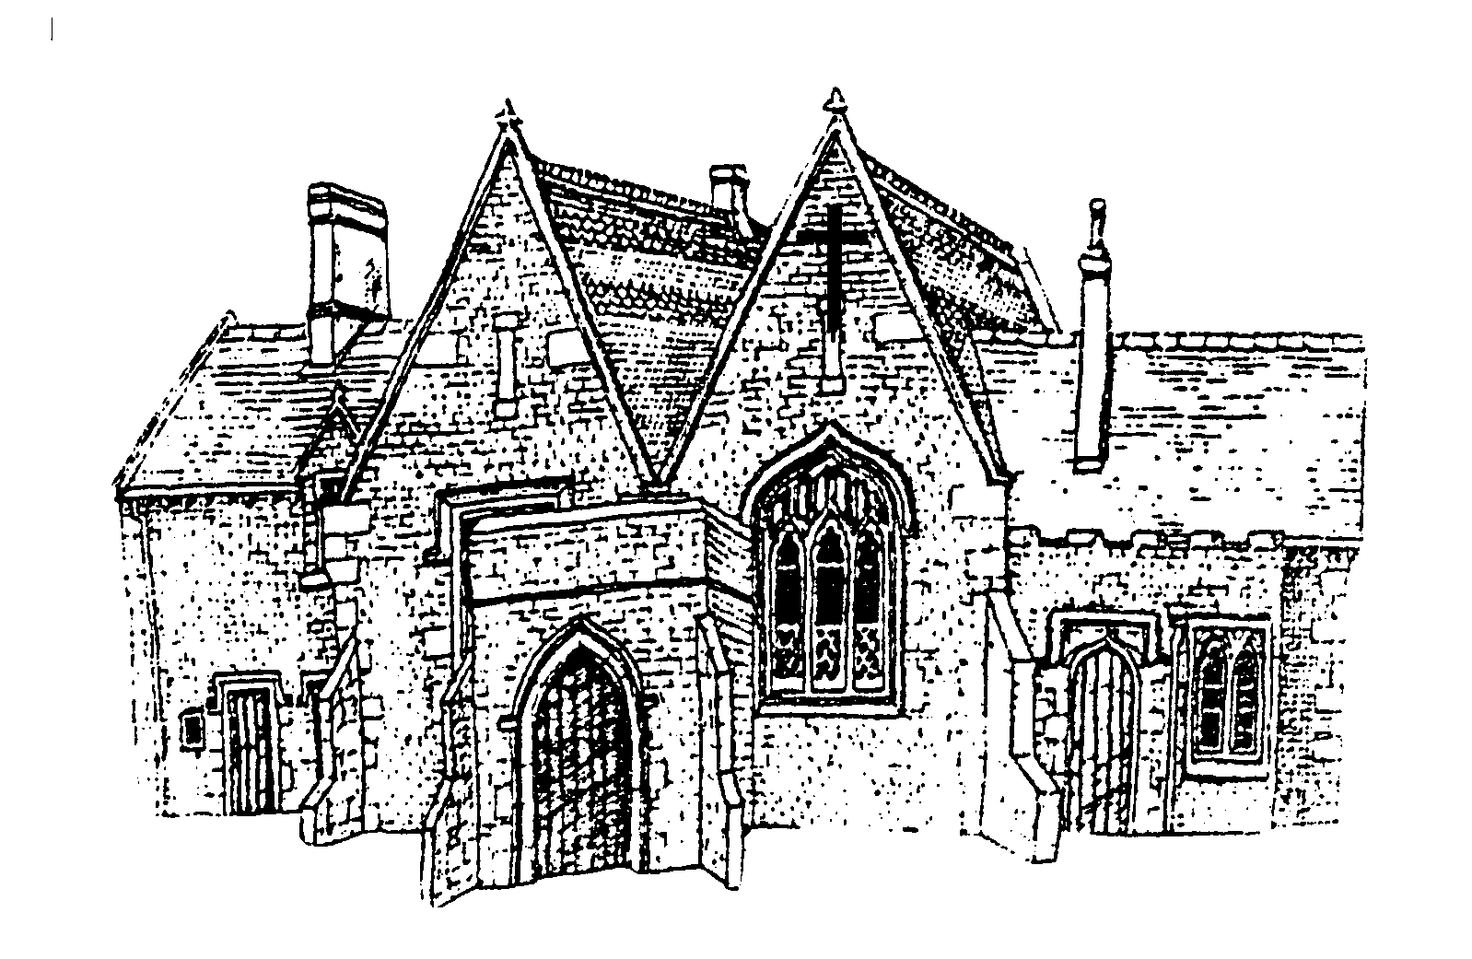

Cubbington CE Primary School

Year 4 – Herons

Summer 2024

**Art and D.T**

Exploring sculpture inspired by artists such as Marcus Coates.

Using sculpture to inspire Greek pots.

Creating electric circuit to use in a product.

**Geography**

Where is Greece? Where is Japan? Contrasting UK countries

**Science**

Investigations focusing on ‘states of matter’ and ‘living things and conservation.

**History**

Greek life and the impact on the Western World. Greek states, the Olympics, The Battle of Marathon and The Trojan War.

**Computing**

Animation, Effective searching, Hardware investigations, Making music

**P.E**

Swimming, Athletics, Rounders, Orienteering

**English**

Autobiographies and fact files using ‘The Matchbox Diary’

Retellings and non-chronological reports using ‘Weslandia’

Packing lists and newspaper reports using ‘Shakleton’s Journey’

Informal letters and factual reports using ‘Granny came here on the Empire Windrush’

Performances and nonsense poems using ‘Jabberwocky’

Guided reading using texts from Literacy Shed

Spelling roots using Spelling Shed

**RE**

Lines of enquiry:

‘Commitment and rites of passage: What is the best way for Jewish people to show commitment to God?’

‘Pentecost: What was the impact for Christians?’

**Music**

Reflect, rewind, replay classical music

Work on music for class assembly

**Other information**

Weekly spelling/ timestable test on Friday

Home learning set on a Friday

Class assembly 3rd May

Multiplication check between 3rd June and 14th June

Camping residential 17th June

**French**

Vocabulary and grammar linked to the topics:

‘What’s the time?’

‘Holidays and hobbies’

**PSHE**

Learning and understanding around the themes of ‘growing up and changing’.

**Maths**

Decimals

Money

Time

Shape

Statistics

Position and direction